Chapter 19
E-Commerce and E-Governance

Lesson 19.1: E-Commerce
Lesson 19.2: E-Governance

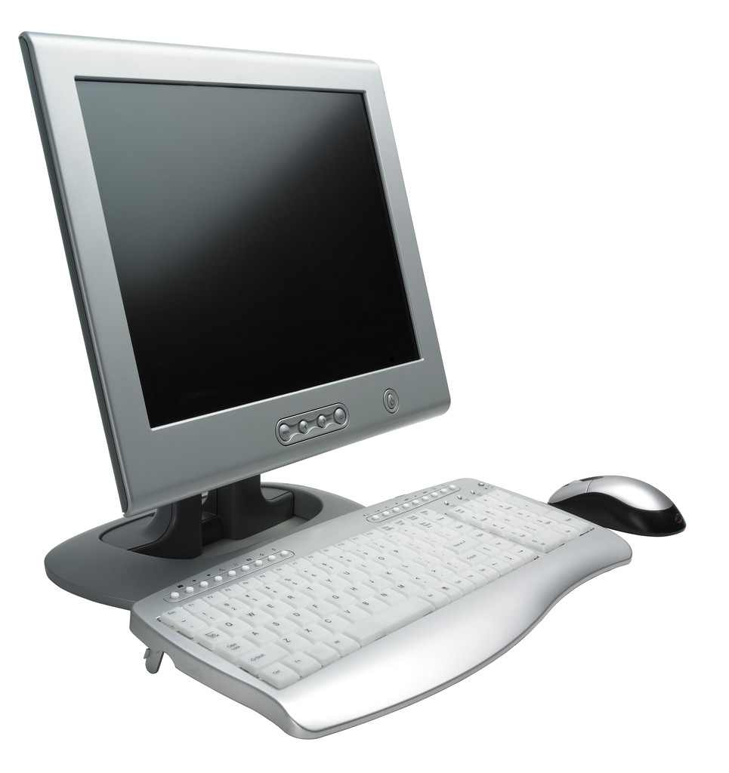

Lesson 19.1
E-Commerce

19.1.0 Objectives
On completion of this lesson you will know:
- Benefit of E-Commerce
- E-commerce Techniques
- Electronic Payment System and Security
- Drawback of E-Commerce

19.1.1 Electronic Commerce (E- Commerce)
With the revolution of Internet, electronic commerce (e-commerce) emerges as an area of business management and information technology. According to the editor-in-chief of International Journal of Electronic Commerce, Mr. Vladimir Zwass:
‘E-commerce is sharing business information, maintaining business relationships and conducting business transactions by means of telecommunications networks’.
The early stage of development of e-commerce was originated from the electronic transmission of messages during the Berlin airlift in 1948. In the 1960s, several industry groups produced a common electronic data formats, and were used primarily for intra-industry transactions. It was not until the late 1970s that work began for national electronic data interchange (EDI) standards, which developed well into the early 1990s. EDI is the electronic transfer of a standardized business transaction between a sender and receiver computer, over some kind of private network or value added network (VAN). Both sides would have to have the same application software and the data would be exchanged in an extremely rigorous format. In sectors such as retail, automotive and heavy manufacturing, EDI was developed to integrate information across larger parts of an organization’s value chain from design to maintenance so that manufacturers could share information with designers, maintenance and other partners and stakeholders. With the advent of the Internet, the term e-commerce began to include:
- Electronic trading of physical goods and of intangibles such as information.
- All the steps involved in trade, such as on-line marketing, ordering payment and support for delivery. The electronic provision of services such as after sales support or on-line legal advice.
- Electronic support for collaboration between companies such as collaborative on-line design and engineering or virtual business consultancy.

19.1.2 Benefits and Limitation of E-Commerce
Benefits of E-Commerce
The benefits of e-commerce can be seen to affect three major stakeholders: organizations, consumers and society.
Benefits to organizations:
- International marketplace: Businesses now have access to people all around the world. In effect, all e-commerce businesses have become virtual multinational corporations.
- Operational cost savings: The cost of creating, processing, distributing, storing and retrieving paper-based information has decreased.
- Mass customization: The pull-type processing allows for products and services to be customized to the customer’s requirements.
- Supply Chain management: It enables reduced inventories and overheads by facilitating ‘pull’-type supply chain management – this is based on collecting the customer order and then delivering through JIT (just-in-time) manufacturing.
- Lower telecommunications cost: The Internet is much cheaper than value added networks (VANs) which are based on leasing telephone lines for the sole use of the organization and its authorized partners. It is also cheaper to send a fax or e-mail via the Internet than direct dialing.
- Digitization of products and processes: Software, books, cards, music and videos etc can be downloaded or e-mailed directly to customers via the Internet in digital or electronic format.
- No more 24-hour-time constraints: Businesses can be contacted by customers or suppliers at any time.
Benefits to consumers:
- 24/7 access. Enables customers to shop or conduct other transactions at any time from almost any location.
- More choices: Customers not only have a whole range of products that they can choose from and customize, but also an international selection of suppliers.
- Price comparisons: Customers can conduct comparisons either directly by visiting different sites, or by visiting a single site where prices are aggregated from a number of providers and compared.
- Improved delivery processes: This can range from the immediate delivery of electronic goods such as software or audio-visual files by downloading via the Internet, to the on-line tracking of the progress of packages being delivered by mail or courier.
- Competitive Business: An environment of competition where substantial discounts can be found customers. It also allows many individual customers to aggregate their orders together into a single order presented to wholesalers or manufacturers and obtain a more competitive price.
Benefits to society:
- Enables more flexible working practices, which enhances the quality of life for a whole host of people in society, enabling them to work from home. Not only is this more convenient and provides happier and less stressful working environments, it also potentially reduces environmental pollution as fewer people have to travel to work regularly.
- Connects people: Enables people in developing countries and rural areas to enjoy and access products, services, information and other people which otherwise would not be so easily available to them.
- Facilitates delivery of public services: e-Health services, such as online consultation with doctors are now available over the Internet. People can also book e-ticket, transfer utility bills and taxes over the Internet.

Limitations of E-Commerce
Limitations for organizations:
- Lack of security, reliability: There are numerous reports of websites and databases being hacked into, and security holes in software. For example, Microsoft has over the years issued many security notices and ‘patches’ for their software.
- Rapidly evolving and changing technology: In order to exploit new opportunities, the business model of an organization is changing rapidly. This may lead to strategies harmful to the organization. Moreover, the business model can easily be copied and followed over the Internet and restricts longer-term competitive advantage.
- Increased Competition: The competition has increased from both national and international competitors that often lead to price wars and subsequent unsustainable losses for the organization.
- Compatibility difficulties: There are problems where older business systems cannot communicate with web based and Internet infrastructures, leading to some organizations running almost two independent systems where data cannot be shared. This often leads to having to invest in new systems or an infrastructure, which bridges the different systems. In both cases this is both financially costly as well as disruptive to the efficient running of organizations.
Limitations for consumers: Computing equipment is needed for individuals to participate in the new ‘digital’ economy, which means an initial capital cost to customers.
- Requirement of IT skills: A basic technical knowledge is required of both computing equipment and navigation of the Internet and the World Wide Web.
- Additional Cost: There is an additional cost of access to the Internet, whether dial-up or broadband tariffs. The technology need to be updated regularly to be compatible with the changing requirement of the Internet, websites and applications.
- Lack of security and privacy of personal data: There is no real control of data that is collected over the Web. Data protection laws are not universal and so websites hosted in different countries may or may not have laws which protect privacy of personal data.
- Loss of physical contact: In the non e-commerce system, customer verifies the good physically before purchase. Customers are unable to touch and feel goods being sold on-line.
- Lack of trust: There is a lack of trust because they are interacting with anonymous computers.
Limitations for society:
- Breakdown in human interaction: In e-commerce, people are interacting with a screen. This is reducing the personal and social skills in society.
- Reliance on telecommunications infrastructure, power and IT skills: E-commerce benefits are nullified in some developing countries, if power, advanced telecommunications infrastructures and IT skills are unavailable or scarce or underdeveloped.
- Wasted resources: In order to include new demands and services, IT infrastructure is changing very quickly. All the old PCs, and other hardware or software might need to replace by disposing.

19.1.3 Categories of E-commerce
The Internet, intranet and extranet provide vital e-commerce links between the business, consumers, government and peers. Based on the transaction partner e-commerce classification is shown in Table 19.1.1. Only popular classes are briefly discussed below:

 |  | Transaction accepted by
 |  | Business | Consumer | Government | Peer
Transaction Initiated from | Business | B-to-B | B-to-C | B-to-G | B-to-P
Transaction Initiated from | Consumer | C-to-B | C-to-C | C-to-G | C-to-P
Transaction Initiated from | Government | G-to-B | G-to-C | G-to-G | G-to-P
Transaction Initiated from | Peer | P-to-B | P-to-C | P-to-G | P-to-P
Table 19.1.1: Categories of E-commerce

Business-to-Business (B-to-B): In B-to-B, the exchange of products, services or information between business entities. Web-based B-to-B includes:
- Direct selling and support to business, the customers of Microsoft windows 7 can buy and also get technical support, downloads, patches online from the Microsoft website.
- E-procurement where a purchasing agent can shop for supplies from vendors, request proposals, and, in some cases, bid to make a purchase at a desired price.
- Information sites provide information about a particular industry for its companies and their employees. These include specialized search sites and trade and industry standards organization sites.
Business-to-consumer (B-to-C): The exchange of products, information or services between business and consumers in a retailing relationship, example: www.bikroy.com.
Business-to-Government (B-to-G): The exchange of information, services and products between business organizations and government agencies on-line. This may include,
- A virtual workplace in which a business and a government agency could coordinate the work on a contracted project by collaborating on-line to coordinate on-line meetings, review plans and manage progress.
- Rental of on-line applications and databases designed especially for use by government agencies.
Business-to-Peer Networks (B-to-P): This would be the provision of hardware, software or other services to the peer networks.
Consumer-to-Business (C-to-B): This is the exchange of products, information or services from individuals to business. A classic example of this would be individuals selling their services to businesses.
Consumer-to-Consumer (C-to-C): In this category consumers interact directly with other consumers. They exchange information such as:
- Expert knowledge where one person asks a question about anything and gets an e-mail reply from the community of other individuals, as in the case of blog sites.
- Opinions where people shares their opinion about companies and products, for example www.gsmarena.com. There is also a selling of goods between people, for example www.bikroy.com.
Consumer-to-Government (C-to-G): In this case, consumers provide services to the government. Such services have yet to be implemented in the country.
Government-to-Business (G-to-B): Government sites offering information, forms and facilities to conduct transactions for business organizations. Government sites now enable the exchange between government and business as given below:
- Information, guidance and advice for business on international trading, sources of funding and support, facilities.
- A database of laws, regulations and government policy for industry sectors.
- On-line application and submission of official forms (such as company and value added tax).
- On-line payment facilities.
This improves accuracy, increases speed and reduces costs, so businesses are given financial incentives to use electronic-form submission and payment facilities.
Government-to-Consumer (G-to-C): It is a case of e-government. Government sites offering information, forms and facilities to conduct transactions for individuals, including paying bills and submitting official forms on-line such as tax returns.
Government-to-Government (G-to-G): It is a case of e-government. Government-to-government transactions within countries linking local governments together and also international governments, especially within the European Union, which is in the early stages of developing coordinated strategies to link up different national systems.

19.1.4 Barriers to E-Commerce
Numerous reports and surveys identify the different kinds of barriers to the growth and development of e-commerce. Many of them focus on security as being one of the main problems for e-commerce. Overall, all kinds of organizations have similar barriers but with different emphases:
- Internet infrastructure: It deals with issues such as availability and quality of the Internet (speed and reliability). SMEs and B-to-C organizations relies more on consumers, availability and quality of the Internet which have a direct impact on their Web-based business.
- Infrastructure: It deals with issues of standardization of systems and applications, which is a particular concern for larger organizations who want to implement solutions such as value chain integration and e-supply-chain management.
- Security: Security is one of the most significant barriers to e-commerce both within the organization and external to it.
- Commercial Infrastructure: The commercial infrastructure relates to issues such as international trade agreements, taxation laws and other legal agreements that facilitate all kinds of on-line trading and so is a barrier relevant to all types of organizations.
- Lack of qualified personnel: There is a lack of qualified personnel to implement in-house and third-party e-commerce systems.
- Interoperability of systems: This refers specifically to implementation and compatibility problems of integrating new e-commerce applications with existing legacy systems and resources within organizations. This problem also extends to interacting with systems of business partners and stakeholders. There is a need for standards to be introduced to overcome issue of incompatibility and interoperability.

19.1.5 Electronic Payment Systems and Security
Electronic Funds Transfer
Electronic Funds Transfer (EFT) is the exchange and transfer of money from one account to another account either within the same and different bank via computer based system. The term covers a number of different concepts, such as
- Card holder initiated transaction using payment card (e.g., credit/debit and cash card).
- Direct Deposit which is initiated by payee
- Electronic case (e.g., Cyber coin) and Electronic Checks (e.g., Net Cheque) for which a business debits the consumer’s bank account for payment for goods or services.
- E-bill in online banking
- Mobile banking and Pay-by-phone
In order to understand EFT, consider that a customer is intended to buy a book using credit card. The steps involved in this electronic payment are as follows (Figure 19.1.2):
Step 1: Customer browses and decides to purchase.
Step 2: Customer sends order and payment information to Merchant.
Step 3: Merchant forwards payment information to Merchant’s Bank.
Step 4: Merchant’s Bank checks with the issuer for payment authorization.
Step 5: Customer’s Bank authorizes payment request.
Step 6: Merchant’s Bank captures transaction.
Step 7: Merchant completes the order.
Step 8: Customer’s Bank sends credit card bill to customer.

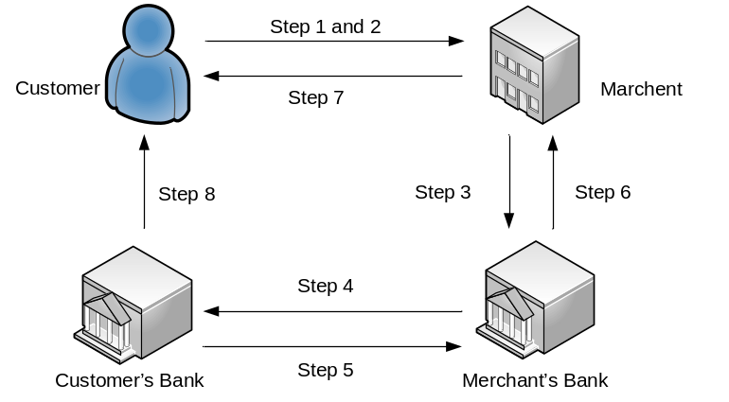
Figure 19.1.2: Electronic Payment using Credit Card

Securing Financial Transactions
SET: Secure Electronic Transaction (SET) is a communication protocol standard for securing financial transactions on the Internet. SET was not itself a payment system, but rather a set of security protocols and formats that enabled users to employ the existing credit card payment infrastructure on an open network in a secure fashion. However, it failed to gain attraction in the market. VISA now promotes the 3-D secure scheme.
SET was supported initially by MC, Visa, Microsoft, Netscape, and others. With SET, a user is given an electronic wallet, called digital certificate, and a transaction is conducted and verified using a combination of digital certificates and digital signatures among the purchaser, a merchant, and the purchaser's bank in a way that ensures privacy and confidentiality. SET makes use of Netscape's Secure Sockets Layer (SSL), Microsoft's Secure Transaction Technology (STT), and Terisa System's Secure Hypertext Transfer Protocol (S-HTTP). SET uses some but not all aspects of a public key infrastructure (PKI)
3D Secure: 3D Secure is an XML-based protocol which includes an additional security layer for online credit and debit card transactions. It was developed by Visa with the intention of improving the security of Internet payments and is offered to customers under the name Verified by Visa. Services based on the protocol have also been adopted by MC, and AmEx.

19.1.6 Keypoints
- E-commerce is sharing business information, maintaining business relationships and conducting business transactions by means of telecommunications networks.
- EDI is the electronic transfer of a standardized business transaction between a sender and receiver computer, over some kind of private network or value added network (VAN).
- The benefits of e-commerce can be seen to affect three major stakeholders: organizations, consumers and society.
- Internet infrastructure, Infrastructure, Security, Lack of qualified personnel etc are the barriers of the deployment of e-commerce.
- Electronic Funds Transfer (EFT) is the exchange and transfer of money from one account to another account either within the same and different bank via computer based system.
- Secure Electronic Transaction (SET) is a communication protocol standard for securing financial transactions on the Internet.
- 3-D Secure is an XML-based protocol which includes an additional security layer for online credit and debit card transactions.

19.1.7 Exercise

Multiple Choice Questions
- E-commerce involves use of _________________.
- people
- computer
- Internet
- None
- Which of the following is not the advantage of e-commerce?
- It makes business as International market place
- It saves operational cost
- It reduces the use of paper
- It reduces development cost
- Government sites offering information, forms and facilities to conduct transactions for business organizations. Which classification of e-commerce is true for it?
- B-to-C
- G-to-C
- G-to-B
- B-to-G
- Expert knowledge where one person asks a question about anything and gets an e-mail reply from the community of other individuals, as in the case of blog sites. Which classification of e-commerce is true for it?
- B-to-C
- B-to-G
- C-to-C
- None.
- Electronic data interchange (EDI) is ___________________.
- the exchange and transfer of money from one account to another account within the same via computer based system
- the exchange and transfer of money from one account to another account within different bank via computer based system
- both
- none.
- Secure Electronic Transaction (SET) is ___________________.
- a hardware for securing financial transactions.
- a communication protocol standard for securing financial transactions on the Internet.
- both
- none.
- 3-D Secure is ____________________ for online credit and debit card transactions.
- an Java-based protocol
- an Java-based protocol which includes an additional security layer
- an XML-based protocol
- an XML-based protocol which includes an additional security layer
Short Question and Answer
- What is E- Commerce?
- Write down the Benefits of E-Commerce
- Write down the disadvantages of E-Commerce
- What are the barriers to e-commerce?
- What do you mean by EFT?
- Distinguish between SET and 3D secure.
Analytical Questions
- Explain different categories of E-commerce.
- Write down the advantages and disadvantages of e-commerce
- Explain electronic funds transfer using an illustration.
- Explain SET and 3D secure.

Lesson 19.2
E-Governance

19.2.0 Objectives
On completion of this lesson you will know:
- E-Government
- Main Focus of E-Government
- Advantages and disadvantages of E-Commerce
- E-government portals and platforms
- Common Models of E-Governance
- Common Models of E-Governance

19.2.1 E-Government
Electronic Government (E-Government) or Digital Government involves employment of the Internet and the world-wide-web for delivering government information and services to the citizens. It refers to the utilization of information and communication technology (ICT) and other web-based telecommunication technologies to improve and/or enhance the efficiency and effectiveness of government service delivery.
It also deals with non-Internet applications to aid in governments. E-government includes the use of electronics in government as large-scale as the use of telephones and fax machines, as well as surveillance systems, tracking systems such as RFID tags, and even the use of television and radios to provide government-related information and services to the citizens.
Essentially, the e-Government delivery models can be briefly summed up as
- G2C (Government to Citizens)
- G2B (Government to Businesses)
- G2E (Government to Employees)
- G2G (Government to Governments)
There are also some technology-specific sub-categories of e-government, such as m-government (mobile government), u-government (ubiquitous government), and g-government (GIS/GPS applications for e-government).
E-Government enables anyone visiting a city website to communicate and interact with city employees via the Internet with graphical user interfaces (GUI), instant-messaging (IM), audio/video presentations, and in any way more sophisticated than a simple email letter to the address provided at the site and the use of technology to enhance the access to and delivery of government services to benefit citizens, business partners and employees.

19.2.2 Main Focus of E-Government
The main focus should be on:
- Use of Information and communication technologies, and particularly the Internet, as a tool to achieve better government.
- Use of information and communication technologies in all facets of the operations of a government organization.
- Continuous optimization of service delivery, constituency participation and governance by transforming internal and external relationships through technology, Internet and new media.

19.2.3 Advantages and Disadvantages of E-Government
Advantages
The main advantages concerning e-government are
- It simplifies delivery of services to citizens and minimizes the government bureaucracy
- It offers an increased portfolio of public services to citizens in an efficient and cost effective manner.
- It helps to simplify processes and makes access to government information more easily accessible for public sector agencies and citizens.
- E-government allows for government transparency. It allows the public to be informed about what the government is working on as well as the policies they are trying to implement. Citizens participate in online discussions of political issues with increasing frequency, and young people, who traditionally display minimal interest in government affairs, are drawn to e-voting procedures.
- It is convenient and cost-effective for businesses, and the public benefits by getting easy access to the most current information available without having to spend time, energy and money to get it.
- It reduces the use of paper. Government of Bangladesh utilizes the website http://www.forms.gov.bd to provide internal government forms for all citizens and thus produce significant savings paper.
- It allows citizens to interact with computers to achieve objectives at any time and any location, and eliminates the necessity for physical travel to government agents sitting behind desks and windows.
- Improved accounting and record keeping can be noted through computerization, and information and forms can be easily accessed, equaling quicker processing time.
- It improves the efficiency of government management

Disadvantages:
The main disadvantages of e-government are
- Lack of equality in public access to the Internet: An e-government site, which provides web access and support, may not reach to all users equally including those who live in remote areas or who have low literacy levels.
- Reliability of information on the web: An e-government site is maintained by the governments themselves. Thus Information on e-government site can be added or removed or updated.
- Agendas bias public opinions: Hidden agendas of government groups that could influence and bias public opinions.
- High development cost: A prodigious amount of money is required for the development and implementation of e-government.
- Vulnerability to cyber attacks: An e-government site has vulnerability to active cyber attacks.
There are many considerations and potential implications of implementing and designing e-government, including disintermediation of the government and its citizens, impacts on economic, social, and political factors, vulnerability to cyber attacks, and disturbances to the status quo in these areas.

19.2.4 E-government portals and platforms
The primary delivery models of e-Government are classified depending on who benefits. In the development of public sector or private sector portals and platforms, a system is created that benefits all constituents. Citizens needing to renew their vehicle registration have a convenient way to accomplish it while already engaged in meeting the regulatory inspection requirement. To develop these public sector portals or platforms, governments have the choice to internally develop and manage, outsource, or sign a self-funding contract. The self-funding model creates portals that pay for themselves through convenience fees for certain e-government transactions, known as self-funding portals.

19.2.5 E-governance
E-governance is the application of ICT to transform the efficiency, effectiveness, transparency and accountability of informational and transactional exchanges within government, or between government and government agencies of municipal and local levels, or between government and citizen. It also empowers citizens through access and use of information.

19.2.6 Common Models of E-Governance
The benefits of E-Governance are faster decision making, reduction of duplication of work, detection of corruption and illegal transactions, prevention of knowledge drain and crisis handling.
The objective of the conventional E-Governance is to help citizens in
- Paying utility bills (telephone, water, electricity, etc.), taxes and so on,
- Handling registration formalities for land ownership, marriage, birth, and death
- Processing application forms and renewals of driving licenses, work permits and passports etc.
- Lodging complaints.
The E-Governance cut the frontiers of time and space. It helps citizens to access information at any time, at any place using net-enabled system. The object of the conventional E-Governance is a set of documents which may be rule books, guidelines, files, applications, circulars, government orders, memorandums, letters, archives and classified information.
This model of E-Governance has two independent components:
- Administration, and
- Citizen and Government.
The administration component has two major subdivisions, which are
- Inter-department and
- Intra department.
In the same way the component of “Citizen and Government” has two major subdivisions such as
- Citizen to government and
- Government to citizen.
Administration
E-Governance entails an Intranet for secure, authenticated inter/intra departmental electronic data interchange. Decision-making and activities of a government of intra department are hierarchy-based. There are two kinds of hierarchies in intra department: official hierarchy and regional hierarchy. Inter-Department activities are such as Sharing of information, Mutual cooperation, and Monitoring and assistance.
Citizen and Government
The financial aspects of Citizen-to-Government are taxes, utility bills, penalties, and toll money etc. The non-financial aspects of Citizen-to-Government are voice of the people, memorandum, requests, and general elections etc.
The financial aspects of Government-to-Citizen are loans, relief funds, B2C transactions, B2B transactions (e-Commerce). E-Governance provides comprehensive B2B / B2C capabilities that connect small-scale industries, traders, farmers and their customers in a cost effective and timely manner. The non-financial aspects of Government-to-Citizen are education and training (e-Learning), opinion polls, survey, intelligence and reports. E-Governance can harness the Internet and cable networks to spread quality education and training across the country.

19.2.7 Keypoints
- E-Government involves the employment of the Internet and the world-wide-web for delivering government information and services to the citizens and other agencies including the government.
- The main focus of e-government should be on the Internet. the use of information and communication technologies and the continuous optimization of service delivery.
- E-government simplifies delivery of services to citizens and minimizes the government bureaucracy, and improves the efficiency of government management.
- The main disadvantage concerning e-government is Lack of equality in public access to the Internet.

19.2.8 Exercise

Multiple Choice Questions
- E-government involves use of _________________.
- people
- computer
- Internet
- None.
- Which of the following is not the advantage of e-commerce?
- It simplifies delivery of services
- It allows government transparency.
- It reduces the use of paper
- It reduces development cost.
- E-governance is the application _____________.
- of ICT to transform the efficiency, effectiveness and transparency
- of ICT to transform the accountability
- both
- none

Review Question
- What is E-Government? Distinguish between E-Government and E-Governance.
- What are the main focuses of E-Government?
- Write down the advantages and disadvantages of E-Government.

Analytical Questions
- Explain the e-Government delivery models.
- Explain E-government portals and platforms.
- Explain a common models of E-Governance

